1. Add a new column called DOB in Persons table with data type as Date.

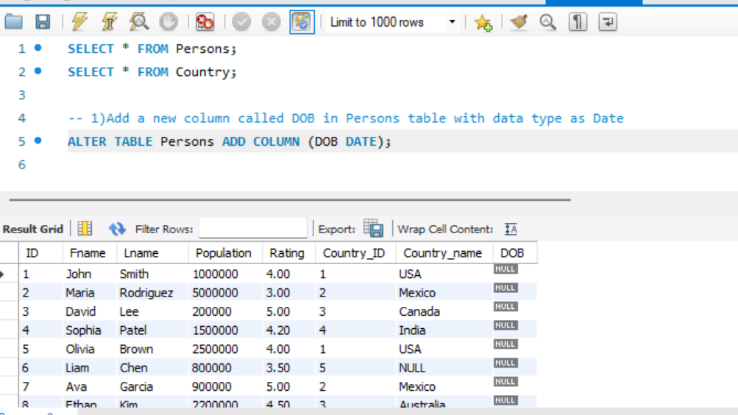

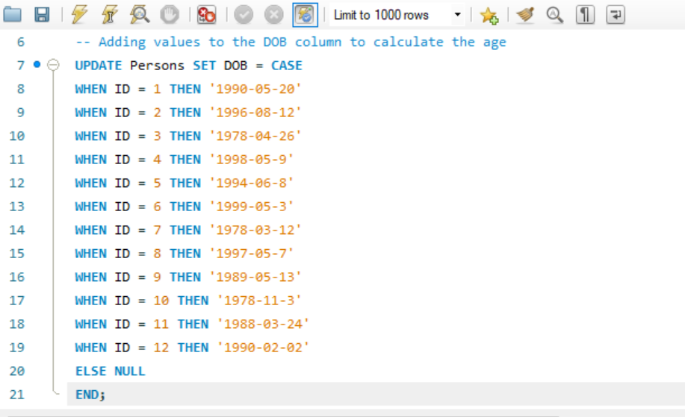

1. Write a user-defined function to calculate age using DOB

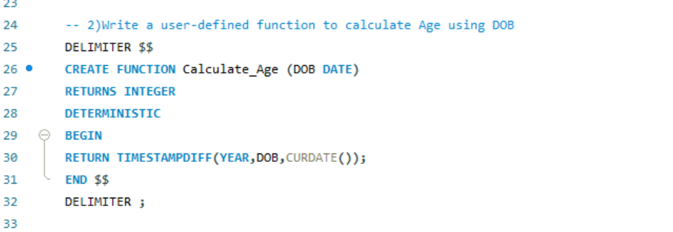

1. Write a select query to fetch the Age of all persons using the function that has been created.

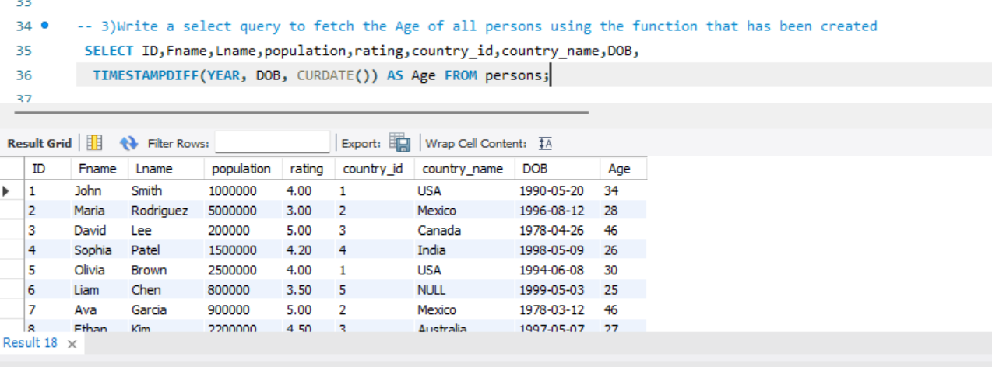

1. Find the length of each country name in the Country table.

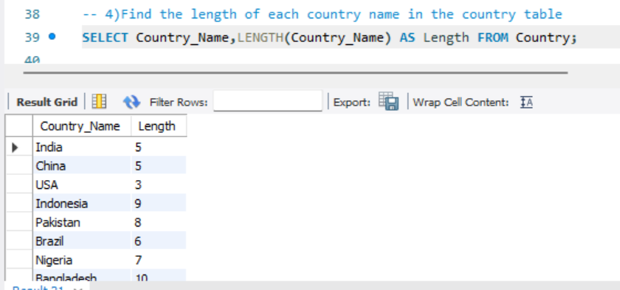

1. Extract the first three characters of each country's name in the Country table.

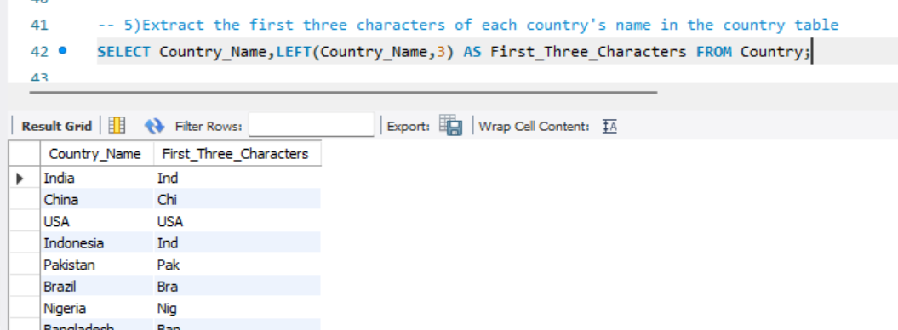

1. Convert all country names to uppercase and lowercase in the Country table.

